*ADOPT AN ATHLETE*

Lacombe Minor Football offers kid's ages 8-15 the chance to learn and develop their athletic skills, good sportsmanship, and leadership in

Lacombe & surrounding areas.

Help support LACOMBE & AREA MINOR FOOTBALL players by adopting one of our awesome players this Season!

ALTHETES FIRST NAME: _____________________

ALTHETES LAST NAME: _____________________

Please Check a division your player is in.

DIVISION: BANTAM FEE $375.00

DIVISION: PEE WEE FEE $325.00

DIVISION: ATOM FEE  $275.00

DIVISION: FLAG FEE  $75.00

OTHER DONATION AMOUNT: _____________

Cheque/payment can be made to:

Lacombe & Area Minor Football

Box 5962

Lacombe Alberta

T4L 1X4

IF A DONATION RECIEPT IS REQUIRED PLEASE PROVIDE NAME AND MAILING ADDRESS BELOW.

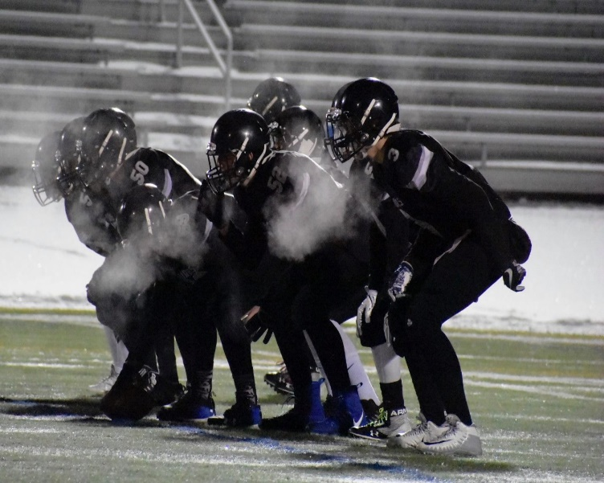

***THANK YOU FOR YOUR SUPPORT!***

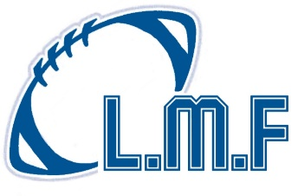

 THANK YOU FOR YOUR SUPPORT!